Student worksheet

6.5 The Big Bang theory is supported by evidence

Pages 148–149

Our expanding universe

1 What is the Big Bang theory?

|  |
| --- |
|  |

2 Why might he word ‘bang’ to describe the beginning of the universe be misleading?

|  |
| --- |
|  |
|  |

3 Use the table below to summarise the key evidence for the Big Bang theory.

|  |  |
| --- | --- |
| Aspect of Big Bang theory | Key evidence |
| Microwave background |  |
| Mixture of elements |  |
| The universe is changing |  |

4 Some scientists say that when we examine distant galaxies, we are looking back in time. What do they mean by this?

|  |
| --- |
|  |
|  |
|  |

Extend your understanding

|  |  |
| --- | --- |
| In 1925 American astronomer Edwin Hubble took a series of images of the nebula M31 (now popularly known as the Andromeda galaxy) and, on comparing them, discovered a Cepheid variable star that he called V1. He measured V1’s period of pulsation to be 31.4 days.  Since a Cepheid variable star’s period of pulsation determines its variation in magnitude, as discovered by American astronomer Henrietta Leavitt, Hubble was then able to calculate how far away V1 was from Earth. He did this by measuring V1’s variation in brightness and, on comparing this with the absolute variation predicted by the relationship discovered by Henrietta Leavitt, Hubble calculated that M31 was 285 000 parsecs away from Earth – this led to it being classified as a galaxy in its own right, and not part of our Milky Way galaxy. The universe had suddenly become a very large place!  In 1929 Hubble published a paper that showed the results of his investigation of the relationship between a galaxy’s radial velocity (derived from its Doppler shift) and its distance from Earth. | L:\1. Publishing and Editorial\1. Product\Oxford Science\Oxford Science 10\3. Extras\6. Student worksheets\Artwork\4. Final jpgs\SW0615_01095-rm.jpg  Edwin Powell Hubble |

Hubble’s data

|  |  |  |  |  |  |  |
| --- | --- | --- | --- | --- | --- | --- |
| Object  name | Distance  (Mpc) | Velocity  (km/s) |  | Object  name | Distance  (Mpc) | Velocity  (km/s) |
| SMC | 0.032 | +170 |  | NGC 3627 | 0.9 | +650 |
| LMC | 0.034 | +290 |  | NGC 4826 | 0.9 | +500 |
| NGC 6822 | 0.214 | –130 |  | NGC 5236 | 0.9 | +500 |
| NGC 598 | 0.263 | –70 |  | NGC 1068 | 1.0 | +920 |
| NGC 221 | 0.275 | –185 |  | NGC 1055 | 1.1 | +450 |
| NGC 224 | 0.275 | –220 |  | NGC 7331 | 1.1 | +500 |
| NGC 5357 | 0.45 | +200 |  | NGC 4258 | 1.4 | +500 |
| NGC 4736 | 0.5 | +290 |  | NGC 4151 | 1.7 | +960 |
| NGC 5194 | 0.5 | +270 |  | NGC 4382 | 2.0 | +500 |
| NGC 4449 | 0.63 | +200 |  | NGC 4472 | 2.0 | +850 |
| NGC 4214 | 0.8 | +300 |  | NGC 4486 | 2.0 | +800 |
| NGC 3031 | 0.9 | –30 |  | NGC 4649 | 2.0 | +1090 |

Note: 1 Mpc = 1 million parsecs = 1.0 × 106 pc

5 Using the data in the above tables, plot a graph of radial velocity (km/s) against distance (Mpc) on the axes provided.

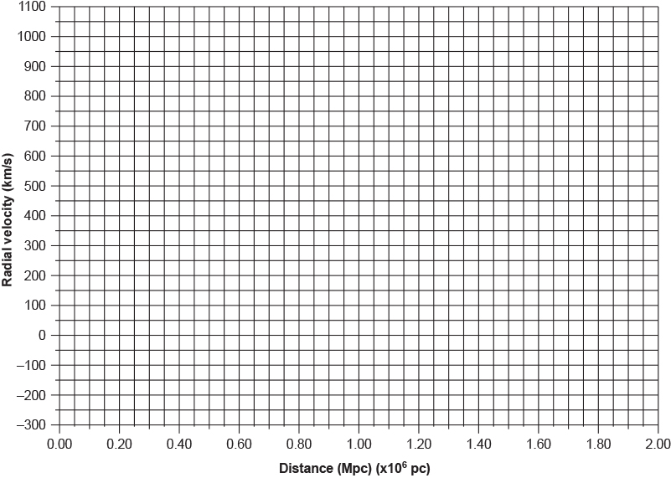

6 What does the general trend of the data suggest about what is happening in the universe? Explain your answer.

|  |
| --- |
|  |
|  |
|  |
|  |

7 Some of the radial velocities in Hubble’s data were negative. What does this tell us about their motion? Can you think of a reason why this might be so, given that the radial velocities of all of the other galaxies have positive values?

|  |
| --- |
|  |
|  |
|  |
|  |
|  |